**CHEMISTRY**

**STAGE 3A SEMESTER ONE EXAMINATION, 2015**

**QUESTION/ANSWER BOOKLET**

**STUDENT NAME: ANSWERS**

**Time allowed for this paper**

Reading time before commencing work: Ten minutes

Working time for paper: Three hours

**Materials required/recommended for this paper**

***To be provided by the supervisor***

This Question/Answer Booklet

Multiple Choice Answer Sheet

Chemistry Data Sheet

***To be provided by the candidate***

Standard items: pens (blue/black preferred, pencils (including coloured, sharpener, eraser, correction fluid/tape, ruler, highlighters

Special items: non-programmable calculators approved for use in the WACE examinations.

**Important note to candidates**

No other items may be taken into the examination room. It is your responsibility to ensure that you do not have any unauthorised notes or other items of a non-personal nature in the examination room. If you have any unauthorised material with you, hand it to the supervisor before reading any further.

**Structure of this paper**

|  |  |  |  |  |  |  |
| --- | --- | --- | --- | --- | --- | --- |
| **Section** | **Number of questions available** | **Weighting** | **Suggested working time (minutes)** | **Marks available** | **Your total score for each section** | **Your total percentage for examination** |
| **Section one: Multiple choice** | **25** | **25** | **50** | **25** |  |  |
| **Section two: Short answer** | **12** | **40** | **60** | **70** |  |  |
| **Section three: Extended answer** | **8** | **35** | **70** | **80** |  |  |
| **Total** | | | | **175** |  | **100** |

**Instructions to candidates**

1. The rules for the conduct of Western Australian external examinations are detailed in the Year 12 information Handbook 2014. Sitting this examination implies that you agree to abide by these rules.

2. Answer the questions according to the following instructions.

Section One: Answer all questions on the separate Multiple-choice Answer Sheet provided. For each question shade the box to indicate your answer. Use only a blue or black pen to shade the boxes. If you make a mistake, place a cross through that square, do not erase or use correction fluid, and shade your new answer. Marks will not be deducted for incorrect answers. No marks will be given if more than one answer is completed for any question.

Sections Two and Three: Write you answers in this Question/Answer Booklet.

3. When calculating numerical values, show your working or reasoning clearly. Express numerical answers to **appropriate** significant figures and include **units** where applicable.

4. You must be careful to confine your responses to the specific questions asked and to follow any instructions that are specific to a particular question.

5. Spare pages are included at the end of the booklet. They can be used for planning your responses and/or as additional space if required to continue an answer.

* Planning: If you use the spare pages for planning, indicate this clearly at the top of the page.
* Continuing an answer: If you need to use the space to continue an answer, indicate in the original answer space where the answer is continued, i.e. give the page number. Fill in the number of question(s) that you are continuing to answer at the top of the page.

**Section One: Multiple-choice 25% (25 Marks)**

This section has 25 questions. Answer all questions on the separate Multiple-choice Answer Sheet provided. For each question shade the box to indicate your answer. Use only a blue or black pen to shade the boxes. If you make a mistake, place a cross through that square, do not erase or use correction fluid, and shade your new answer. Marks will not be deducted for incorrect answers. No marks will be given if more than one answer is completed for any question.

Suggested working time: 50 minutes

**_____________________________________________________________________________**

1. Nitrogen is a really important element necessary for healthy plant growth. The following are all fertilisers capable of dissolving with the nitrogen present becoming available to plants. Which one of following would provide the greatest amount of nitrogen per gram of fertiliser?

1. Ammonium sulfate ( (NH4)2SO4). 21.2%
2. Urea ( (NH2)2CO). 46.7%
3. Ammonium nitrate (NH4NO3). 35.0%
4. Ammonium dihydrogen phosphate (NH4H2PO4). 12.2%

**The next two questions refer to the following information:**

A solution containing 0.050 moles of hydroxide ion, OH – (aq), is added to another solution containing 0.025 moles of calcium ion, Ca 2+ (aq). The reaction that occurs is shown below:

Ca 2+ (aq) + 2OH – (aq) ⭢ Ca(OH)2 (s)

The solid formed is carefully filtered, dried and weighed and found to be 0.015 moles of calcium hydroxide (Ca(OH)2).

2. The amount of hydroxide ion remaining in solution was

1. 0.005 moles
2. 0.020 moles nOH- in ppt = 2 x 0.015 = 0.03 mol , ER = 0.050 – 0.030
3. 0.025 moles
4. 0.035 moles

3. The fact that some hydroxide ions remained in solution suggest that

1. Ca 2+ ions and OH – ions do not react in the ratio of 1 : 2.
2. Ca 2+ ions do not precipitate well with OH – ions. d) is a better answer
3. Some of the Ca(OH)2 has evaporated during the drying process.
4. Ca(OH)2 is slightly soluble and the reaction did not go to completion.

4. Element X has the electron configuration of 2, 4 and element Y has the electron configuration of 2, 7. What is the most likely formula of a compound formed between X and Y?

1. X2Y5
2. X5Y2
3. X4Y
4. XY4

5. Consider a sealed system in which CaCO3, CaO and CO2 are in equilibrium. Now consider the following actions:

K=[CO2] other species are solids, thus ↓ V is [CO2] causes left shift; add gas also shifts left; T ↑ shifts right; thus I, III and IV all change [CO2] and correct answer is c.

1. Add more CO2 (g) to the system.
2. Add more CaCO3 (s) to the system.
3. Decrease the volume of the system.
4. Increase the temperature of the system.

One or more of these actions lead to a change in CO2 (g) concentration (after equilibrium is established). Which statement is true?

1. All actions lead to a change in CO2 concentration.
2. Only II, III and IV lead to a change in CO2 (g) concentration.
3. Only I, III and IV lead to a change in CO2 (g) concentration.
4. Only IV leads to a change in CO2 (g) concentration.

6. Which one of the following may have 17 protons, 19 neutrons and 18 electrons?

1. Cl
2. Cl –
3. K
4. K +

7. Which of the following statements about the boiling point of non-polar covalent molecular substances is TRUE?

1. Boiling point is the temperature at which there is sufficient energy to overcome the intermolecular dispersion forces.
2. Boiling point is the temperature at which hydrogen bonds form in the liquid phase.
3. Boiling point is the temperature at which the covalent bonds within each molecule are overcome.
4. The boiling point is the temperature at which the valence electrons have been removed from all the atoms in the molecule.

8. Which of the following molecules contains only one lone pair (non-bonding pair) of valence electrons?

1. Chlorine gas (Cl2).
2. Methane gas (CH4).
3. Ammonia gas (NH3).
4. Hydrogen gas (H2).

9. Which of the following statements about carbon – containing substances is TRUE?

1. Carbon atoms in diamond are bonded covalently to three other carbon atoms in three different directions.
2. Carbon atoms in graphite bond to four other carbon atoms to produce small planar clusters of atoms held together by dispersion forces.
3. Carbon atoms in methane bond to four hydrogen atoms to form a tetrahedral shaped molecule with bond angles of 109.5 º.
4. In carbon dioxide, the central carbon atom has two double bonds and two lone pairs of electrons.

10. Which row below correctly list examples of the main intermolecular forces existing between the substances shown?

|  |  |  |  |
| --- | --- | --- | --- |
|  | Hydrogen Bonding | Dipole-dipole Forces | Dispersion Forces |
| (a) | H2S | HF | HCl |
| (b) | H2Te | NH3 | F2 |
| (c) | H2O | HF | CH4 |
| (d) | H2O | HCl | C2H6 |

11. Reactions that show an increase in the rate of reaction due to an increased temperature can best be explained by

1. The temperature lowering the activation energy.
2. An increase in the number of particle collisions per unit time.
3. The increased temperature causing the reactant’s bonds to weaken.
4. The change in Enthalpy difference.

12. An element has the following first five successive ionisation energies (in kJ mol – 1):

600 1200 4900 6500 8200

Which of the following elements is it?

1. Calcium
2. Argon
3. Sodium
4. Aluminium

13. Carbon dioxide molecule is linear and the sulfur dioxide molecule is bent. If both carbon-oxygen and sulfur-oxygen bonds are polar, which one of the following statements is TRUE?

(a) Both CO2 and SO2 are polar, but CO2 is more polar than SO2.

(b) Both CO2 and SO2 are polar, but SO2 is more polar than CO2.

(c) CO2 is polar but SO2 is not.

(d) SO2 is polar but CO2 is not.

14. Consider the structures shown below:

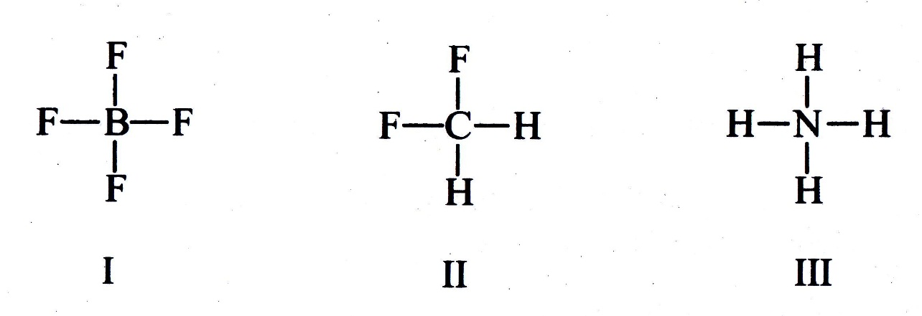

Which of the following statements is true?

1. I and II are ions.
2. I and III are ions.
3. II and III are ions.
4. None of I, II and III are ions.

15. In a chemical reaction, 2.40 g of substance X (with a molar mass of 64.0 g mol – 1) reacts with exactly 250.0 mL of a 0.0500 mol L – 1 solution of Y to produce substance Z. The values of *a* and *b* in the equation: *a*X + *b*Y ⭢ *c*Z are, respectively

1. 2, 2
2. 1, 3
3. 3, 1
4. 2, 3

16. As atomic number increases across a period, which one of the following generally decreases?

1. Atomic mass.
2. Number of valence electrons.
3. First ionisation energy.
4. Atomic radius.

17. A solution contains a potassium ion (K+) concentration of 45.2 ppm. Assuming the mass of one litre of the solution is 1010 g, what is the concentration in mol L – 1 of potassium chloride present?

45.2 mg/kg x 1.010 kg/L x 1 g/1000 mg = 0.04565 g/L

0.04565 g/L / 39.10 g/mol = 1.17 x 10-3 mol/L K ion therefore KCl

1. 1.15  10 – 4 mol L – 1
2. 6.12  10 – 4 mol L – 1
3. 4.52  10 – 3 mol L – 1
4. 1.17  10 – 3 mol L – 1

18. If 150 mL of water was added to 200 mL of 0.239 mol L – 1 AlCl3 solution, the concentration of the chloride ions in the final solution would be:

c = ([200 x 0.239] / 350) x 3 = 0.4096 mol/L

1. 0.137 mol L – 1
2. 0.358 mol L – 1
3. 0.410 mol L – 1
4. 0.717 mol L – 1

19. A student reacts excess hydrochloric acid (HCl) with 0.125 moles of a metal (M). **Hydrogen** gas and a soluble metal chloride are produced. The volume of hydrogen gas produced is 4.257 L at S.T.P. What is the valency of the metal ion produced in solution when the reaction is complete?

n = 4.257/22.71 = 0.18745 mol = 0.2 mol

n(Cl- and H+) = 0.4

M to Cl- ratio is 0.125 : 0.4 = 1 : 3.2

1. + 4
2. + 3
3. + 1
4. + 2

20. Two separate closed systems are set up and allowed to come to equilibrium.

System 1: H2 (g) + I2 (g) ⮀ 2HI (g)

System 2: H2 (g) + S (g) ⮀ H2S (g)

The pressure on both systems is then doubled by halving the volume. Once the system has re-established equilibrium you would expect that:

1. The equilibrium position would shift toward products in both systems since both reactions would proceed faster.
2. The concentration of HI would decrease in System 1.
3. The concentration of H2S would increase in System 2.
4. The concentration of reactants and products would not change in either of the systems.

**THE NEXT TWO QUESTIONS REFER TO THE FOLLOWING INFORMATION.**

When dilute hydrochloric acid is added to a solution of potassium chromate (yellow), a solution of potassium dichromate (orange) is produced. This is an example of a reversible reaction where there are no visible changes to the colour of the solution formed once equilibrium has been reached. The equation for the reaction is shown below:

2CrO4 2 – (aq) + 2H + (aq) ⮀ Cr2O7 2 – (aq) + H2O (l) + 42 kJ

21. Which of the following would NOT favour the forward reaction?

1. Addition of more potassium chromate.
2. Increasing the concentration of hydrochloric acid.
3. Decreasing the temperature of the solution.
4. Addition of water.

22. What would you expect to happen to the colour of the solution if dilute sodium hydroxide is added?

1. The solution would become more intensely orange due to the forward reaction being favoured.
2. The solution would become yellow due to the reverse reaction being favoured.
3. The solution would remain orange due to the fact that sodium hydroxide is not one of the reacting species in this reaction.
4. The solution would become colourless due to the forward reaction producing more water molecules.

23. Sodium uranyl perchlorate, NaUO2(ClO4)3 is soluble in water and dissolves to form the following ions – Na + (aq), UO2 2+ (aq), and ClO4 – (aq). When 1 mole of this compound completely dissolves in water, what is the relative concentrations of each of the ions – Na + (aq), UO2 2+ (aq), and ClO4 – (aq) – in that order?

1. 1 : 1 : 1
2. 1 : 2 : 1
3. 1 : 1 : 3
4. 1 : 2 : 3

**THE NEXT QUESTION IS BASED ON THE FOLLOWING INFORMATION.**

Phoebe carries out a practical test. She is given unlabelled test tubes containing 1 mol L– 1 solutions of cobalt bromide, sodium iodide, sodium nitrate and copper (II) sulfate and asked to identify which compound is which. She chooses to use solutions of silver nitrate and sodium hydroxide to test samples of all four unknowns, which she labels 1, 2, 3 and 4 and gets the following results.

|  |  |  |  |  |
| --- | --- | --- | --- | --- |
| Test solution | Test Tube 1 | Test Tube 2 | Test Tube 3 | Test Tube 4 |
| Addition of AgNO3 | No reaction | Cream solid formed | White solid formed | Yellow solid formed |
| Addition of NaOH | No reaction | Red solid formed | Blue solid formed | No reaction |

24. Using Phoebe’s observations, what is the probable identity of the four solutions?

|  |  |  |  |  |
| --- | --- | --- | --- | --- |
|  | Test Tube 1 | Test Tube 2 | Test Tube 3 | Test Tube 4 |
| (a) | NaNO3 | CuSO4 | CoBr2 | NaI |
| (b) | NaNO3 | CoBr2 | CuSO4 | NaI |
| (c) | NaI | CoBr2 | CuSO4 | NaNO3 |
| (d) | NaI | CuSO4 | CoBr2 | NaNO3 |

25. What mass of silver chloride will form when 50.0 mL of 0.0200 mol L – 1 silver nitrate solution is added to an excess of sodium chloride solution?

1. 0.001 g
2. 0.108 g
3. 0.143 g
4. 0.179 g

**END OF SECTION ONE**

**Section Two: Short Answer 35% (70 Marks)**

This section has 12 questions. Answer ALL questions. Write your answers in the spaces provided.

Spare pages are included at the end of this booklet. They can be used for planning your responses and/or additional space if required to continue an answer.

* Planning: If you use the spare pages for planning, indicate this clearly at the top of the page.
* Continuing an answer: If you need to use the space to continue an answer, indicate in the original answer space where the answer is continued, i.e. give the page number. Fill in the number of the question(s) that you are continuing to answer at the top of the page.

Suggested working time: 60 minutes.

**_____________________________________________________________________________**

**Question 26 6 Marks**

The following equilibrium is being investigated:

2 ZnS (s) + 3O2 (g) ⮀ 2 ZnO (s) + 2 SO2 (g) ΔH = - 879 kJ

Three identical sealed boxes are set up, each containing the equilibrium mixture. Each of the boxes is treated as described below, and time is allowed for a new equilibrium to be established. In each case describe the change between the original equilibrium and the new equilibrium

|  |  |  |
| --- | --- | --- |
| Treatment | What happens to the rate of the forward reaction? Write ‘increases’, ‘decreases’ or ‘no change’. | What happens to the equilibrium position? Write ‘move to the right’, ‘move to the left’ or ‘no change’. |
| A small amount of O2 is added. | Increase | Shift right |
| Ne (g) is pumped in, increasing the pressure of the system (no volume change). | No Change | NO Change |
| The reaction vessel is heated | Increase | Shift left |

**Question 27 2 Marks**

In order to test the carbonic acid (H2CO3) content of soda water, a chemist takes a 250 mL bottle of soda water and dilutes a 20.0 mL sample of it by making this up to 500 mL in a volumetric flask. If the diluted soda water is found to have a carbonic acid concentration of 0.2636 mol L – 1, what is the concentration of carbonic acid in the original 250 mL of soda water?

**V1c1 = V2c2**

**c1 =**

**Question 28 4 Marks**

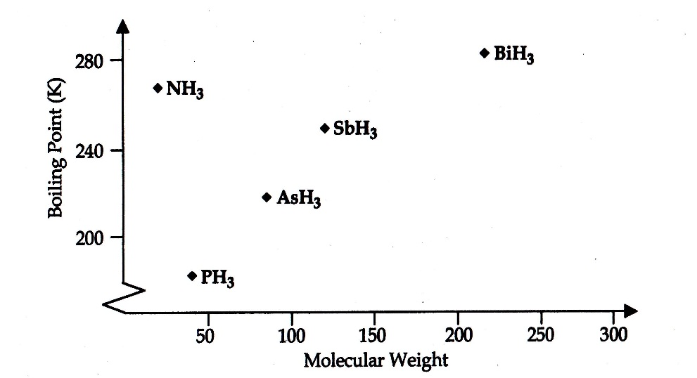

The boiling points of the hydrides of the Group 15 elements are shown on the graph right:

(a) Account for the trend in boiling points from PH3 to BiH3.

increasing electrons;

increasing dispersion forces between molecules;

nb – all molecules are polar, pyramidal

(b) Account for the relatively high boiling point for NH3.

N highest electronegativity;

hydrogen-bonding between ammonia molecules;

much stronger than dipole-dipole between others;

**Question 29 7 Marks**

This question asks you to predict properties of elements from their positions in the Periodic Table. The symbols of the eight elements are shown in the outline of the Periodic Table below. Answer the questions that follow about these eight elements.

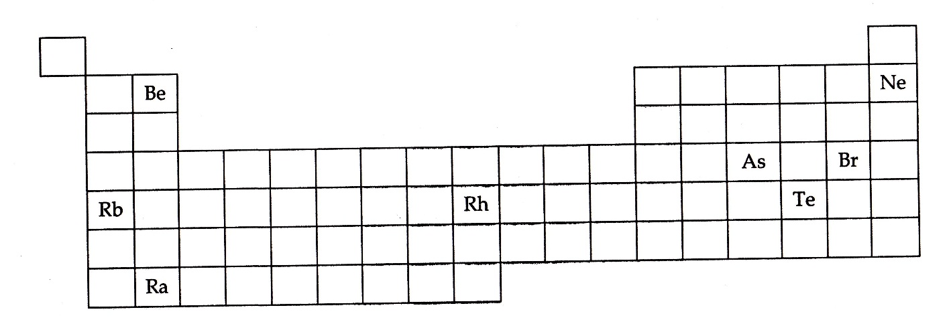

(a) Write the symbol of the element with the highest electronegativity.

Answer: Br

(b) Write the formula of the hydride of Te.

Answer: H2Te or TeH2

(c) Write the symbol of the element with the lowest first ionisation energy.

Answer: Rb (403 kJ/mol) nb Ra (509 kJ/mol)

(d) Write the formula of an acid of Te containing four oxygen atoms.

Answer: H2TeO4

(e) Write the symbol of the element which is a monatomic gas at room temperature.

Answer: Ne

(f) Write the formula for the carbonate of Rb.

Answer: Rb2CO3

(g) Write the formula of a basic oxide of one of the elements.

Answer: BeO or Rb2O or RaO

**Question 30 6 Marks**

(a) Write a chemical equation which is consistent with the observation in the following experiment. (2 Marks)

|  |  |  |
| --- | --- | --- |
| What is done | Observation | Equation |
| A colourless, odourless liquid is added to a white solid. | The white solid dissolves, and a colourless, odourless gas bubbles off, leaving a colourless solution. | 2HCl(aq) + Na2CO3(s) → 2NaCl(aq) + H2O(l) + CO2(g) |

(b) Give a test which would confirm the identity of the gas produced in the reaction in (a). (4 Marks)

|  |  |
| --- | --- |
| What test is done | Bubble the gas through limewater, Ca(OH)2(aq). (1, allow ecf from a) |
| What is observed | The limewater goes from clear to opaque white. A colourless odourless gas bubbled through a clear solution gives a white precipitate and a clear solution. (1, allow ecf from a) |
| **Give the test equation** | **CO2(g) + Ca(OH)2(aq) → CaCO3(s) + H2O(l) (2, must have states for full marks)** |

**Question 31 3 Marks**

Petrol and kerosene do not easily remove adhesive residue from price stickers, but methylated spirits (ethanol – CH3CH2OH) is effective. Explain why this might be so.

dissolving involves breaking intermolecular bonds between the adhesive and surface as well as between the solvent molecules;

bonds formed between the solute and solvent need to be of similar strength;

hydroxyl (-OH) group is polar;

will dissolve polar substances in adhesive;

kerosene and petrol are completely non-polar;

**Question 32 8 Marks**

Fill in the boxes of the table below with a molecule, chosen from the list provided, that matches the description in the box. While there may be more than one molecule that matches the description, only one answer per box is required.

**CH4 CH2O CH2Cl2 NO2 – HF Na + BF3 Cl2 H2O NH3**

|  |  |  |  |
| --- | --- | --- | --- |
| A bent, polar species | A non-polar species | A species that can form hydrogen bonds between its molecules of the same type | A triangular planar, non-polar species |
| H2O, NO2- | CH4, Cl2 | NH3, H2O, HF | BF3 |
| A tetrahedral polar species | A triangular planar, polar species | A pyramidal species | A species that only contains non-polar bonds |
| CH2Cl2 | CH2O | NH3 | Cl2 |

**Question 33 6 Marks**

Write chemical equations, including states, for any reaction that occur in the following procedures. In each case, describe what would be observed, including any colour changes, odours, precipitates or gases evolved. If the reaction occurs without any observable changes, you should state this.

(a) Copper (II) nitrate solution is added to sodium carbonate solution. (3 Marks)

Equation:

Cu(NO3)2(aq) + Na2CO­3(aq) → CuCO­3(s) + 2NaNO3(aq) OR

Cu2+(aq) + CO­32-(aq) → CuCO­3(s) (1, must include states)

Observations:

blue soln added to clear soln;

green solid in clear soln produced;

(b) A piece of potassium metal is placed in a glass trough containing water. (3 Marks)

Equation:

2K(s) + 2H2O(l) → 2KOH(aq) + H2(g) (1, states req’d)

Observations:

silver/grey solid floats on clear liquid;

bursts into lilac flame, disappears, releases colourless gas, forms clear soln; (needs all effects for point).

**Question 34 9 Marks**

The ‘Thermite reaction’ is a spectacular chemical reaction in which finely powered aluminium and iron (III) oxide are mixed and ignited. A bright, hot flame is observed and molten iron and aluminium oxide are produced.

(a) Write the chemical equation for the reaction. (1 Mark)

2Al(s) + Fe2O3(s) → 2Fe(l) + Al2O3(s)

(b) Explain why the aluminium and iron (III) oxide must be finely powdered and thoroughly mixed. (2 Marks)

in order for the particles to react they must collide, ensured by mixing;

powdering increases surface area, increasing collisions;

(c) This reaction does not occur at room temperature. One way to start the reaction is to drop a piece of burning magnesium ribbon onto the mixture. Why is it necessary to start the reaction this way? (2 Marks)

reaction must have a high activation energy;

provided by the burning magnesium;

(d) Using the following axes, draw a reaction profile diagram for the thermite reaction. On your diagram label the **activation energy** and **ΔH**. (3 Marks)

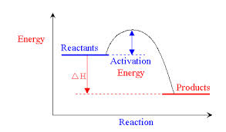

(e) Is the reaction endothermic or exothermic? exothermic (1 Mark)

**Question 35 9 Marks**

For each species listed in the table below, draw the structural formula, representing all valence shell electron pairs either as : or – . State or draw the shape of the molecule and indicate the polarity of the molecule.

|  |  |  |  |
| --- | --- | --- | --- |
| Species | Structure (showing all the valence shell electrons) | Shape (sketch or name) | Polarity of species (write ‘polar’ or ‘non-polar’) |
| Difluorochlorine (I) cation (ClF2 +) | **+**  **F**    Cl F | bent | polar |
| Nitrogen trifluoride (NF3) |  | pyramidal | polar |
| Sulfur trixoxide (SO3) |  | Trigonal/triangular planar | Non-polar |

**Question 36 4 Marks**

The percentage of chlorine in an organic pesticide is found by converting all of the chlorine present in a 3.55 g sample of the compound to chloride ion then precipitating this chloride ion as silver chloride. In this procedure 0.975 g of silver chloride was obtained. Use this data to determine the percentage of chlorine in the organic pesticide.

n(AgCl) = $\frac{m}{M}= \frac{0.975 g}{143.35 g/mol}=0.006802 mol AgCl (2)$

m(Cl) = $n x M=0.006802 mol x 35.45\frac{g}{mol}=0.2411 g Cl$ (1)

%Cl(w/w) = $\frac{0.2411 g}{3.55 g} x 100=6.79\%$ (1)

**Question 37 6 Marks**

Lime (calcium oxide) can be prepared industrially by the decomposition of limestone. The limestone is placed into a well ventilated kiln at atmospheric pressure and the system is heated to 1000 ºC. The reaction is shown below:

CaCO3 (s) ⮀ CaO (s) + CO2 (g) ΔH = + 178 kJ mol – 1

(a) Explain why the reaction is carried out in the kiln (a kiln is a furnace or oven for burning, baking or drying something) at a very high temperature and low pressure.

(3 Marks)

forward reaction is endothermic;

high T, low P both shift equilibrium right;

increases yield;

(b) Explain why the kiln is well ventilated. (2 Marks)

removal of CO2(g);

favours forward reaction;

(c) Why will equilibrium never be established in this reaction vessel? (1 Mark)

not a closed system

**End of Section Two**

**This page left intentionally blank.**

**Section Three: Extended answer 40% (80 Marks)**

This section contains six (6) questions. You must answer all questions. Write your answers in the spaces provided.

Where questions require an explanation and/or description, marks are awarded for the relevant chemical content and also for coherence and clarity of expression. Lists or dot points are unlikely to gain full marks.

Final answers to calculations should be expressed to three (3) significant figures.

Spare pages are included at the end of the booklet. They can be used for planning your response and/or as additional space if required to continue an answer.

* Planning: If you use the spare pages for planning, indicate this clearly at the top of the page.
* Continuing an answer: If you need to use the space to continue an answer, indicate in the original answer space where the answer is continued, i.e. give the page number. Fill in the number of the question(s) that you are continuing to answer at the top of the page.

Suggested working time: 70 minutes.

**____________________________________________________________________________**

**Question 38 12 Marks**

A 1.00 g sample containing 72% by mass of Na2SO4 and 28% by mass of another metal sulfate, MSO4, is dissolved in water and the sulfate ions are precipitated as BaSO4. If the precipitate weighs 1.7257 g, find the relative atomic mass of M. What metal could M be?

1.00 g x $\frac{28}{100}=0.28 g of MSO_{4}$ (1)

1.00 g x $\frac{72}{100}=0.72 g of {Na}_{2}SO_{4}$ (1)

n(BaSO4) = (2)

n(Na2SO4) = (2)

n(SO4 from MSO4) = 0.007397 – 0.005071 = 0.002326 mol (2)

m(SO4 from MSO4) = nM = 0.002326 mol x (32.01+(4x16)) g/mol = 0.2233g (1)

A(M) = $\frac{(0.28 g – 0.2233 g) }{0.002326 mol}=24.38 g/mol$ (2)

M is magnesium (1)

**Question 38 continues…**

**Question 39 11 Marks**

The effervescence in indigestion tablets is due to the reaction between sodium hydrogencarbonate and citric acid. An indigestion tablet is found to contain 1.998 g of sodium hydrogencarbonate (NaHCO3) and 1.111 g of citric acid (H3C6H5O7). Citric acid is a triprotic acid and the sodium citrate (Na3C6H5O7) formed is soluble. The other products are water and carbon dioxide.

(a) Write a balanced molecular equation for the reaction. (1 Mark)

3NaHCO3(s) + H3C6H5O7(s) → Na3C6H5O7(aq) + 3H2O(l) + 3CO2(g)

(b) If the tablet has been dissolved in 120.0 mL of water, what will be the concentration in mol L – 1 of the excess reactant? (7 Marks)

(c) What volume of carbon dioxide will be produced from the tablet at a temperature of 37 ºC and a pressure of 99.2 kPa? (3 Marks)

(b)

n(NaHCO3) =

M(NaHCO3) = 22.99 + 1.008 + 12.01 + (3x16.00) = 84.008 g/mol (1)

n(H3C6H5O7) =

M(H3C6H5O7)=(8x1.008)+(6x12.01)+(7x16.00)=192.124 g/mol (1)

3:1 n(NaHCO3) would need acid, acid LR, NaHCO3 is ER (1)

n(ER)=0.0238-(3x0.0058) = 0.00645 mol (1)

c = $\frac{0.00645}{0.120}=0.054\frac{mol}{L}(1)$

**Question 39 continues…**

(c)

n(CO2) = 3 x 0.0058 = 0.0174 mol (1)

T = 37 + 273.15 = 310.15 K (1)

V = $\frac{0.0174 x 8.314 x 310.15}{99.2}=0.452 L or 452 mL (1)$

**Question 40 24 Marks**

Oxygen is one of the most commercially important gases obtained from the atmosphere. At least half of the pure oxygen produced is utilised in the steel industry. The oxygen is blown through the molten impure iron to react with some of the impurities present, such as carbon and sulfur, to produce an alloy of iron (steel) possessing the required properties. Oxygen is very important in the health industry where it is used to assist patients with breathing difficulties such as premature babies and pneumonia patients. The reaction of oxygen with acetylene, producing a temperature of around 3450 ºC, is also used by metal workers and plumbers to cut and weld steel.

Air is composed of 78 % by volume nitrogen, 21 % oxygen. 0.03 % argon, 0.03% carbon dioxide and has traces of other gases. Oxygen is isolated from air by a process called cryogenic (cold temperature) distillation, which depends on the gases having different boiling points. The boiling points of the three most abundant gases in the atmosphere are – 196 ºC (nitrogen), – 183 ºC (oxygen) and – 186 ºC (argon). Modern separation plants can isolate samples of these gases that are 99.9999% pure using the method described as follows.

In this industrial process, the air is first purified, to remove unwanted components such as dust, water vapour and carbon dioxide, and then compressed and cooled. A portion of the purified compressed air is decompressed in a device called a centrifugal expander. As the air expands, its temperature drops until if begins to liquefy at about – 190 ºC. The liquid air is fed into the top of a fractional distillation column containing perforated trays. At the same time, the remaining compressed portion of the air is fed into the bottom of the column. The gaseous air rises up the tower, bubbling through the holes in the trays. Because the gas is warmer than the liquid, the liquid is heated and begins to boil. The gas also cools down and a temperature gradient is set up in the tower with the temperature at the bottom being warmer than the temperature at the top. The gas with the lowest boiling point will therefore boil off from the liquid air higher up the column. Oxygen has the highest boiling point of the three gases and so it remains a liquid at the bottom of the column. It is collected from here either as a liquid or compressed into gas cylinders at a pressure of around 1.55  10 4 kPa.

(a) Draw electron dot diagrams for O2 (oxygen), N2 (nitrogen) and Ar (argon). (3 Marks)



**Ar**

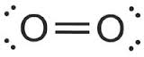

(b) Discuss why oxygen (O2) and nitrogen (N2) exist as diatomic molecules but argon (Ar) does not. (3 Marks)

oxygen and nitrogen unstable electron configuration;

share electrons in covalent bonds;

Argon has stable electron configuration;

**Question 40 continues…**

(c) Explain why oxygen, nitrogen and argon have very low boiling points. (3 Marks)

oxygen and nitrogen are non-polar molecules;

all 3 have dispersion forces only;

weakest intermolecular force;

(d) Explain why oxygen has a higher boiling point than nitrogen. (1 Mark)

Oxygen has 12 electrons to nitrogen’s 10, higher dispersion forces;

(e) Discuss why argon has a lower boiling point that oxygen. (1 Mark)

Argon is monatomic, fewer electrons, lower dispersion forces;

**Question 40 continues…**

(f) During the distillation process which of the three elements present will vaporise first as the liquid moves down the column? Explain you answer. (2 Marks)

lowest bp = lowest intermolecular forces;

nitrogen vaporises first;

(g) Explain why air liquefies at a temperature of about – 190 ºC and not – 196 ºC (the boiling point of the gas present in the largest amount). (2 Marks)

air is a mixture/solution of different molecules;

other molecules get in the way of the nitrogen, increasing the bp;

(h) What is an alloy? How does the structure of an alloy differ from that of the pure metal element? (3 Marks)

mixture where the parent element is a metal;

metal cation lattice altered/disrupted;

by different size ions/atoms surrounded by delocalised electrons;

(i) Why is iron from the blast furnace converted into steel rather than being used as formed in the furnace? (2 Marks)

steel is alloy of iron with carbon;

less likely to rust/greater strength/has different properties to iron;

(j) The production of steel from iron ore can be summarized by the following equation:

Fe2O3(s) + 3CO(g) ⮀ 2Fe(l) + 3CO2(g)

Referring to the above reaction give **two** reasons why hot carbon monoxide gas is blasted through iron ore during the steel – making process to increase the yield. (2 Marks)

Increasing the concentration of CO shifts equilibrium toward products;

The CO2 gas is removed by the blast also causes the equilibrium to shift towards the products.

(k) Why is pure oxygen used, rather than air, to react with the acetylene (C2H2) during oxy-acetylene welding? (2 Marks)

produces more heat per unit time;

by increasing reaction rate;

by making it more likely to produce CO2(g) rather than CO(g);

1 pt only for contaminants/side-reactions;

**Question 41 6 Marks**

The analysis of a gold ore sample by atomic absorption spectroscopy involves dissolving a 2.479 g sample of ore and making this up to 50 mL in a volumetric flask. The resulting solution is then analysed for its gold content using an atomic absorption spectrometer. The concentration of gold in the solution is found to be 2.90  10 – 6 mol L – 1. Determine the mass of gold in the 50 mL solution and so calculate the concentration of gold in the ore sample in parts per million.

n = cV = 2.9x10-6 x 0.05 = 1.45x10-7 mol (1)

m = nM = 1.45x10-7 mol x 197 g/mol = 2.85x10-5 g gold (1)

m(Au in mg) = $2.85x{10}^{-5} g x \frac{1000 mg}{1 g}=2.85x{10}^{-2} mg$ (1)

m(sample in kg) = $2.479 x \frac{1 kg}{1000 g}=2.479 x {10}^{-3} kg (1)$

ppm = $\frac{mg solute}{kg soln}=\frac{2.85x{10}^{-2} mg}{2.479 x {10}^{-3} kg}=11.5$ ppm (2)

**Question 42 8 Marks**

The composition of a Cu(OH)2/CuCO3 mixture was examined by heating the sample to decompose the CuCO3 to CuO and CO2. The resulting CO2 (g) was absorbed by NaOH pellets, which subsequently increased in mass. A steady flow of nitrogen gas is used to flush CO2 (g) from the reaction vessel into the tube of NaOH pellets. The NaOH pellets absorb the carbon dioxide gas and increase in mass by 11.03 g. Use the data given on the diagram to calculate the percentages of Cu(OH)2 and CuCO3 respectively in the original mixture.

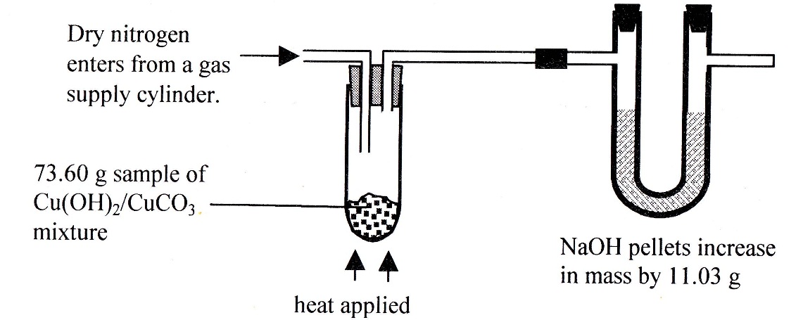

CuCO3(s) → CuO(s) + CO2(g) (1)

n(CO2) = n(CuCO3) (1)

n(CO2) = n(CuCO3)

M(CuCO3) = 63.55 + 12.01 + (3x16) = 123.56 g/mol (1)

m(CuCO3) = nM = 0.2506 x 123.56 = 30.96 g (1)

%(CuCO3) = (1)

%(Cu(OH)2) = 100 – 42.07 = 57.93% (1)

**Question 43 7 Marks**

In the blast furnace, iron oxide is reduced to iron by coke according to the following reactions:

2C (s) + O2 (g) ⭢ 2CO (g)

Fe2O3 (s) + 3CO (g) ⭢ 2Fe (l) + 3CO2 (g)

If the conversion of coke to carbon monoxide is only 40.0 % efficient, determine the mass of coke required to produce 1.00 tonne of iron.

n(Fe) = $\frac{m}{M}=\frac{1x{10}^{6} g}{55.85 g/mol}=17905 mol$ (2)

n(CO) = $\frac{3}{2} x 17905=26858 mol$ (1)

n(C) = 1:1 = 26858 mol (1)

m(C) = nM = 26858 x 12.01 = 322,560 g (1)

m(C) req’d = $\frac{100}{40} x 322,560=806,401 g or 0.8 tonne or 8.06x{10}^{5} g$ (1)

Significant figures and unit (1)

**Question 44 6 marks** Sulfuric acid can be manufactured by the following series of reactions:

4FeS2(s) + 11O2(g) <==> 2Fe2O3(s) + 8SO2(g)

2SO2(g) + O2(g) <==> 2SO3(g) ∆H = -196kJ

SO3(g) + H2O(l) <==> H2SO4(l)

a) Calculate the mass of sulfuric acid which can be produced from 1500 kg of FeS2.

(4 marks)

n(FeS2) = (1)

n(H2SO4) = x 12,501 = 25,002 mol H2SO4 (1)

M(H2SO4) = (2x1.008) + 32.07 + (4x16) = 98.086 g/mol (1)

m(H2SO4) = nM = 25,002 x 98.085 = 2.45x106 g or 2.45 tonne or 2450 kg (1)

b) Explain two ways that the yield of SO3 could be maximized in step 2 of the above reactions.

(2 marks)

high pressure would favour yield as fewer molecules in product;

low/moderate temperature as high T favours reverse;

removal of SO3(g) to keep concentration low would shift equil right;

any 2, but must justify for point ie cannot be “list”

**Question 45 6 marks**

One method of preparing chlorine gas in the laboratory is to react hypochlorous acid (bleach) with hydrochloric acid. The following reaction occurs:

HOCl(aq) + HCl(aq) → H2O(l) + Cl2(g)

In one such experiment, 150.0 mL of 0.502 mol L-1 hydrochloric acid was added to 500.0 mL of a bleach solution which contained 4.00 g of HOCl per litre.

(a) Determine the limiting reagent in this reaction. (4 marks)

n(HCl) = cV = 0.502 x 0.150 = 7.53 x 10-2 mol (1)

n(HOCl) = 10-2 mol (2)

1:1 therefore HOCl is LR (1)

(b) Calculate the volume of chlorine gas obtainable from the above experiment if it is measured at STP. (2 marks)

1:1 therefore n(Cl2(g)) = 3.81 x 10-2 mol (1)

V = n x 22.71 = 3.81 x 10-2 x 22.71 = 0.866 L (1)

**END OF QUESTIONS**

**Question no. ______Question no. ______Question no. ______**



Semester 1 Chemistry 3A

[Grab your reader’s attention with a great quote from the document or use this space to emphasize a key point. To place this text box anywhere on the page, just drag it.]

[Grab your reader’s attention with a great quote from the document or use this space to emphasize a key point. To place this text box anywhere on the page, just drag it.]

[Grab your reader’s attention with a great quote from the document or use this space to emphasize a key point. To place this text box anywhere on the page, just drag it.]

[Grab your reader’s attention with a great quote from the document or use this space to emphasize a key point. To place this text box anywhere on the page, just drag it.]

[Grab your reader’s attention with a great quote from the document or use this space to emphasize a key point. To place this text box anywhere on the page, just drag it.]

[Grab your reader’s attention with a great quote from the document or use this space to emphasize a key point. To place this text box anywhere on the page, just drag it.]

[Grab your reader’s attention with a great quote from the document or use this space to emphasize a key point. To place this text box anywhere on the page, just drag it.]

[Grab your reader’s attention with a great quote from the document or use this space to emphasize a key point. To place this text box anywhere on the page, just drag it.]

[Grab your reader’s attention with a great quote from the document or use this space to emphasize a key point. To place this text box anywhere on the page, just drag it.]

[Grab your reader’s attention with a great quote from the document or use this space to emphasize a key point. To place this text box anywhere on the page, just drag it.]

[Grab your reader’s attention with a great quote from the document or use this space to emphasize a key point. To place this text box anywhere on the page, just drag it.]

[Grab your reader’s attention with a great quote from the document or use this space to emphasize a key point. To place this text box anywhere on the page, just drag it.]

[Grab your reader’s attention with a great quote from the document or use this space to emphasize a key point. To place this text box anywhere on the page, just drag it.]

[Grab your reader’s attention with a great quote from the document or use this space to emphasize a key point. To place this text box anywhere on the page, just drag it.]

[Grab your reader’s attention with a great quote from the document or use this space to emphasize a key point. To place this text box anywhere on the page, just drag it.]

[Grab your reader’s attention with a great quote from the document or use this space to emphasize a key point. To place this text box anywhere on the page, just drag it.]

[Grab your reader’s attention with a great quote from the document or use this space to emphasize a key point. To place this text box anywhere on the page, just drag it.]

[Grab your reader’s attention with a great quote from the document or use this space to emphasize a key point. To place this text box anywhere on the page, just drag it.]

[Grab your reader’s attention with a great quote from the document or use this space to emphasize a key point. To place this text box anywhere on the page, just drag it.]

[Grab your reader’s attention with a great quote from the document or use this space to emphasize a key point. To place this text box anywhere on the page, just drag it.]

[Grab your reader’s attention with a great quote from the document or use this space to emphasize a key point. To place this text box anywhere on the page, just drag it.]

[Grab your reader’s attention with a great quote from the document or use this space to emphasize a key point. To place this text box anywhere on the page, just drag it.]

[Grab your reader’s attention with a great quote from the document or use this space to emphasize a key point. To place this text box anywhere on the page, just drag it.]

[Grab your reader’s attention with a great quote from the document or use this space to emphasize a key point. To place this text box anywhere on the page, just drag it.]

[Grab your reader’s attention with a great quote from the document or use this space to emphasize a key point. To place this text box anywhere on the page, just drag it.]